**Test Document for Post Order Receipt History**

Add new column "Approval / Comment category" in report Post Order Receipt History.

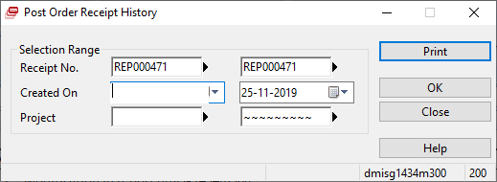

Result: New column Approval/Comment Category added in report.

